|  |
| --- |
|  |
| October 2024 Newsletter |
|  |

Morse Middle School for the Gifted and Talented

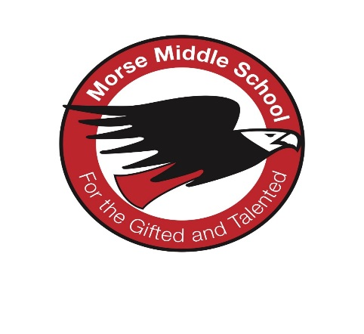

**Upcoming Events**

**Oct. 10th & 16th**

**Parent/Teacher Conference**

**4:30-8:15 pm**

**Oct. 11th Packer Day**

**October 18-21 No School – Fall Break**

**Oct. 25th Food Truck Incentive**

**October 31 Halloween Dance/ Costume Contest**

|  |
| --- |
|  |
| Principal  Mrs. Phyllis Anderson  Assistant Principals  Mr. Gregory Coleman  Dr. Ebony Davis |

[**https://schools.milwaukee.k12.wi.us/morse/**](https://schools.milwaukee.k12.wi.us/morse/) **(414) 393-3500**

[**https://sites.google.com/milwaukee.k12.wi.us/morse/home**](https://sites.google.com/milwaukee.k12.wi.us/morse/home)

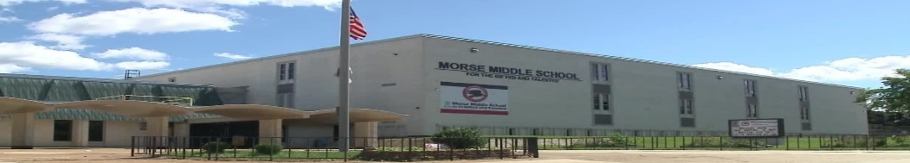

**The Morse Mission Statement**

**We envision every student at Morse Middle School for the Gifted and Talented will grow academically, socially, and emotionally to become life long-learners, productive citizens and future leaders of our community and the world.**

**More Important News**

**IMPORTANT NEWS**

**Parrent Teacher Conferences Thursday, October 10th and Wednesday, and October 16, 2024.**

**Green Schools Park Grand Opening**

**October 8th saw our ribbon cutting and Grand Opening for our Schoolyard development plan. Check out our new playground area.**

**PARENT PICK-UP!**

**Calls for Student Pick-Up must be made by 3:30pm! Pick-Up ends at 3:30pm and resumes at 4:15pm. No calls will be taken between 3:30 and 4:15pm. Parents must come into the building to sign out students for early dismissal.**

Parents, please fill out the school Engagement Survey 2024-25

Here is the link:

<https://mpsresearch.co1.qualtrics.com/jfe/form/SV_8vthsN2BBv09xpY>

Parrents Sign Up for the Parent Portal !!!

Parents are needed for the School Engagement Council and the District Advisory Council (DAC).

Contact Mr. Wright. Email: [wrightp2@milwaukee.k12.wi.us](mailto:wrightp2@milwaukee.k12.wi.us) or (414)393-3536

**Sports Corner**

**Girls Basketball Schedule Flag Football Schedule**

**10/12/2024 1:00 pm 10/12/2024 9:00 am**

|  |  |
| --- | --- |
| **10/19 1:00 pm 10/19 10:00am**  **10/26 1:00 pm**  **11/02 11:am Games at Custer Stadium** | **1:00 pm** |

**Games at Obama SCTE Gym**

**The first 3 students to answer ALL of the questions correctly will receive a prize. You must email Mr. Wright at** [**wrightp2@milwaukee.k12.wi.us**](mailto:wrightp2@milwaukee.k12.wi.us) **with your correct answers.**

**Question 1:** There is only one word spelled wrong in the dictionary. What is it??

**Question 2**: Which is correct to say, “The yolk of the egg are white?” or “The yolk of the egg is white?”

**Question 3**: If a rooster laid a brown egg and a white egg, what kind of chicks would hatch?

**Question 4:** What is the only number that has the same number of letters as its meaning?