April 2026 Newsletter
Morse Middle School for the Gifted and Talented
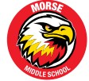
UPCOMING EVENTS
April 15 – Half day
April 23 – Open House
April 25 – Refugee & Immigrant Fair, 10am @ South Division
April 30 – Regular school Day
May 1 – PD day
May 25 – Memorial Day

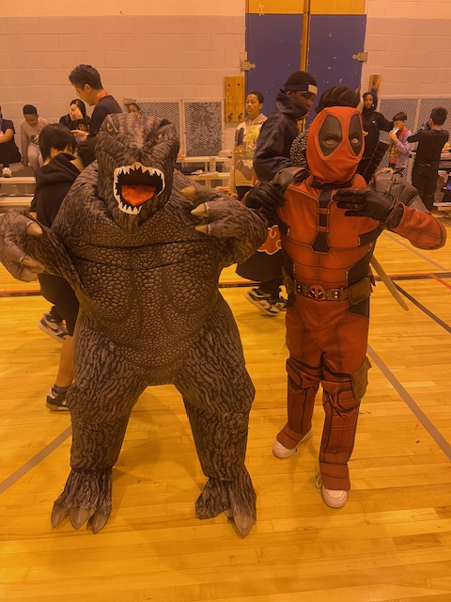
Principal

Mrs. Phyllis Anderson

Assistant Principals

Mr. Gregory Coleman

Dr. Ebony Davis

Websites: Phone: (414) 393-3500
https://schools.milwaukee.k12.wi.us/morse/
https://sites.google.com/milwaukee.k12.wi.us/morse/home
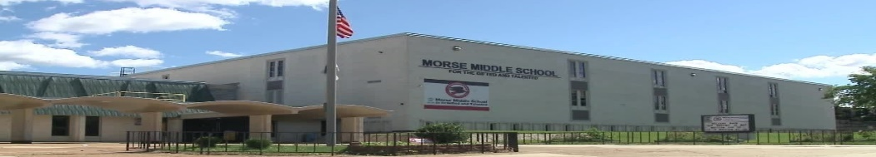
The Morse Mission Statement
We envision every student at Morse Middle School for the Gifted and Talented will grow academically, socially, and emotionally to become life long-learners, productive citizens and future leaders of our community and the world.

The Social Studies class has two upcoming field trips:


Congratulations Dr. Yeng

2026 Wisconsin Prestigious Teacher Award winner!
Morse Middle School for the Gifted and Talented is honored to announce that Dr. Enock Yeng, has been designated as a 2026 Herb Kohl Educational Foundation Teacher Fellow. This elite distinction is conferred upon educators who demonstrate an exhaustive commitment to pedagogy, sophisticated leadership, and a transformative impact on student achievement.
The Social Studies Class has one upcomng field trip May 7, 2026 at 11:30am to the Milwaukee Arts Museum. Cost per student is 0$, it’s a fully funded trip.

DATA
Our attendance rate is 83.6%. Our goal is to have 95% attendance
or better. Our suspension rate is 30.9%, which is down .5% from last year..

Parents Read To Your Children Every Night !!!
Seventh-grade students need to read at least 20 minutes per night and record their minutes read on their monthly reading logs. This is their daily homework assignment.
Reading daily will help build vocabulary and improve reading comprehension. If a person reads 20 minutes per night, they will read approximately 1.8 million words per year!

Students don’t forget to purchase your Yearbook!!

Please follow the rules!
- No food allowed in the gym or auditorium!
- Food is not to be taken out of the cafeteria !
- When entering the building, please take binders and umbellas out of your bookbag before going thru metal detectors!
Parents we are looking for you to be a member of the DAC and SEC!!
Please contact Mr. Wright to join.

April 25 – Refugee and Immigrant Resource Fair. Join us for the 7th Annual Refugee and Immigrant Resource Fair, a day of community, celebration, and support! This free, family-friendly event offers everything from live performances to essential household
resources. April 25, 2026, | 10:00 a.m. – 1:00 p.m. | South Division High School, 1515 W. Lapham Blvd.
For questions, contact Risa Berg, school social worker, at bergrm@milwaukee.k12.wi.us or (414) 902-8373.
April 29 – College & Career Readiness Night
The School Counseling Department invites middle school students and families to attend the College & Career Readiness Night on April 29, 2026, at the MPS Central Services Auditorium. This engaging evening will provide valuable information on high school planning, study skills, college preparation, financial aid, and student wellness. Dinner will be provided from 5:00–5:30 p.m., followed by the program from 5:30–7:30 p.m.

Congrats to the Chess Team!! 

Congratulations are, in order, for the Chess Team for a very successful season! ♟️🥳🏆

The Hawks placed fifth in the K-8 division at the Wisconsin State Chess Championships held March 21-22 near Madison. Additionally, Morse had a great showing at the WSCF Wisconsin Grade Level Championship, where Morse's 8th-grade team took first place, and the 7th-grade team placed second.

"What is impressive is that the players learn the game in middle school," says chess coach and Morse school social worker Cathleen Pollock. "They are often playing against students that have played all throughout elementary school. I'm so impressed and proud of them. They have outplayed former state champs this year and were only two points behind them at the state meet this past weekend."

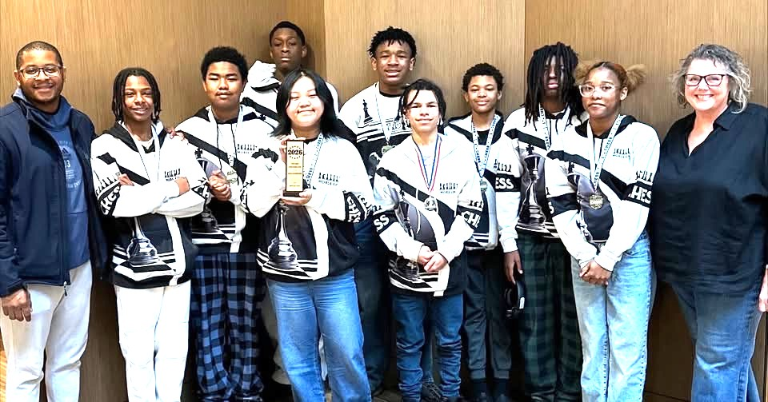



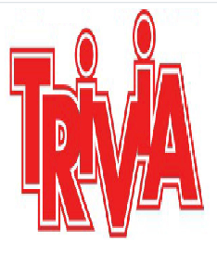

The first 3 students to answer ALL questions correctly will receive a prize. You must email Mr. Wright at wrightp2@milwaukee.k12.wi.us with your correct answers.

Question 1: In "The Matrix," what color pill does Neo take??
Question 2: Which blood type is a universal donor?
Question 3: How many pounds are in a ton?
Question 4: What are the prime factors of 24?

