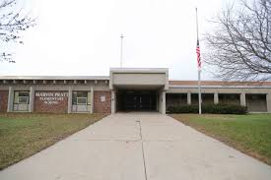

**Marvin Pratt Elementary School**

**5131 N. Green Bay Ave**

**Milwaukee, WI 53209**

**414-247-7300**

**Principal: Tianna Evans**

**Marvin Pratt Elementary School**

**January 2023 Newsletter**

***The vision of Pratt Elementary School is to maintain its status as one of the highest performing elementary schools in the state. We will develop a society of reflective, progressive thinking life-long learners who strive to embody the spirit of innovation, active collaboration, and international mindedness in the pursuit of knowledge.***



## **Dr. Martin Luther King Jr. Day 2023**

**January 16**

**(No school Attendance)**





**Immediate Enrollment**

**Enrollment Windows: 2023-2024 School Year**

* **Kindergarten Enrollment:**  
  February 4 to March 5, 2023
* **High School Enrollment:**  
  October 1 to October 30, 2022
* **All other grade levels that need enrollment for Fall 2023**  
  February 4 to August 1, 2023
* **After the enrollment windows have closed, enrollment will reopen for fall:**
* High School:

February 4 to August 1, 2023

* Kindergarten:  
  April 10 to August 1, 2023

### **Questions about enrollment?**

<https://mps.milwaukee.k12.wi.us/en/Schools/How-to-Apply/Immediate-Enrollment.htm>

**Email:**   
[enrollmentsupport@milwaukee.k12.wi.us](mailto:enrollmentsupport@milwaukee.k12.wi.us?subject=)  
**Phone:** 414-475-8159

**Martin Luther King Jr. was an American Baptist minister and activist, one of the most prominent leaders in the civil rights movement from 1955 until his assassination in 1968**.

<https://www.calendardate.com/martin_luther_king_day_2023.htm>

<https://www.history.com/topics/black-history/martin-luther-king-jr>

**NEW DATES**

**The District Advisory Council**:

Executive Committee: moved the January 5, 2023, DAC meeting to Thursday, January 12, 2023, at 6:00 pm via Zoom.

**School Engagement Council:**

January 19, 2023, at 3:00 pm Marvin Pratt School

**Marvin Pratt “Rockets”** 

**Milwaukee Public School Kindergarten Enrollment Fair on Saturday, February 4, 2023, from 9:00 A.M. to 12:00 P.M. Details will follow soon.**

**Brrrrrr… It’s Cold Outside!**

[](https://www.bing.com/images/search?q=child%20winter%20coat%20and%20glove%20images&id=C9240134A4F062E9B03FD965C740EF394FBBDD4C&FORM=IQFRBA)

During the next few months, the outside temperatures can drop and it can become very cold. Parents, please remember to dress your child appropriately as we do go outside daily for recess. (**Hats, Gloves, Coats, Boots**). Remember, school does not begin until 7:20am, so please keep that in mind when dropping off children. Staff does not report to the playground until then.

**Important Dates**

January 3, 2023 School Resumes

January 10, 2023 Star Assessments Begin

January 12, 2023 District Advisory Council

January 16, 2023 Dr. Martin Luther King Day

(No school Attendance on MLK Day)

January 19, 2023 School Engagement Council



**MARVIN PRATT’S SCHOOL BASKETBALL TEAM SCHEDULES 2023**



<https://acrobat.adobe.com/link/review?uri=urn:aaid:scds:US:6bd0c190-1af0-39c4-a1a3-e57704cf032d\>

**Marvin Pratt Uniform Dress Code**

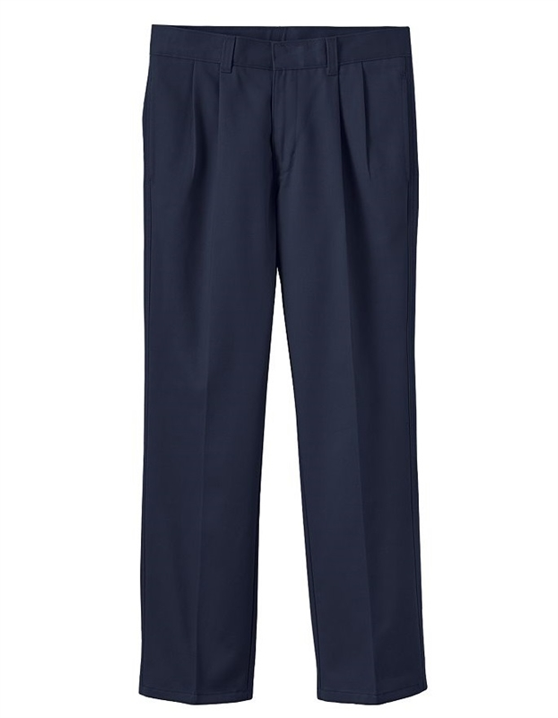

**Uniforms**

**We wear our uniforms Monday through Friday! Please come dressed for success in your navy bottoms and navy, white or light blue tops. When your child shows up out of uniform this affects that classroom’s percentage and they may not be eligible for winning awards for their classroom’s.**

**STAR TESTING STARTS ON NEXT TUESDAY, JANUARY 10, 2023**

**What are Star Assessments?**

Star Assessments are short tests that provide teachers with learning data. Star tests are computer adaptive, which means they adjust to each answer your child provides. This helps teachers get the best data to help your child in the shortest amount of testing time (about one-third of the time other tests take). Your child may take a Star test for early literacy, math, reading, or other subjects of their teacher’s choice.

**PARENTS, PLEASE READ!**

**(TEST TAKING TIPS)**

• Make sure that your child gets a good night’s sleep.

• Be encouraging - let your child know that you think he/she will do well on the test.

• Plan for the morning ahead – lay out clothes to wear; have backpack ready to go.

**THE DAY OF THE TEST:**

• Get up early to avoid rushing.

• Have your child eat a good breakfast. Remember – sugary foods can make your child drowsy.

• Have your child dress in something comfortable. • If your child wears an assistive device, such as a hearing aid or glasses, be sure that he/she remembers to wear them to school.