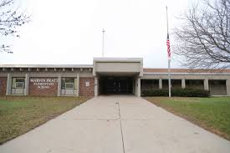

**Marvin Pratt Elementary School**

**5131 N. Green Bay Ave**

**Milwaukee, WI 53209**

**414-247-7300**

**Principal: Tianna Evans**

**Marvin Pratt Elementary School**

November 2023 Newsletter

***The vision of Pratt Elementary School is to maintain its status as one of the highest performing elementary schools in the state. We will develop a society of reflective, progressive thinking life-long learners who strive to embody the spirit of innovation, active collaboration, and international mindedness in the pursuit of knowledge.***

FAMILY CONNECTION

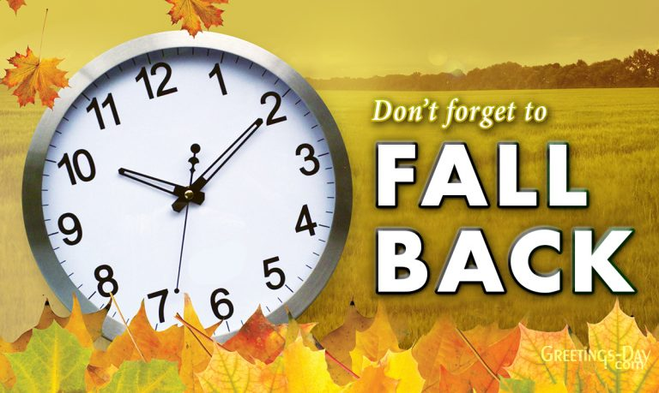

**DAY LIGHT SAVINGS!**

**GET READY TO TURN YOUR CLOCKS BACK**

**SUNDAY, NOVEMBER 5, 2023 AT 2:00AM**

**SCHOOL ENGAGEMENT COUNSIL**

**SCHOOL ENGAGEMENT COUNCIL MEETS EVERY THIRD THURSDAY. A PLACE AT SCHOOL THAT BRINGS TOGETHER FAMALIES, STAFF AND THE COMMUNITY TO SUPPORT AND INFORM SHARED LEADERSHIP, EQUITY, AND CULTURAL RELEVANCE RUSLTING IN INCREASED STUDENT ATTENDANCE. NEXT MEETING IS NOVEMBER 16, 2023 AT 3:00PM**

**DISTRICT ADVISORY COUNSIL**

**THE DISTRICT ADVISORY MEETS ONCE A MONTHLY VIA ZOOM.**

**DURING THESE MEETINGS, PARENTS OF ALL STUDENTS HAVE OPPORTUNITIES TO SHARE THEIR IDEAS ABOUT THE NEEDS OF STUDENTS AND ASSIST IN THE OPERATIONS OF PROGRAMS FOR CHILDREN AND PARTICIPATE IN EVALUATING THE SUCCESS EFFORTS. NEXT MEETING IS NOVEMBER 2, 2023 AT 6:00PM.**

**.**

**Veterans Day Nov11,2023**

**Thank you, Parents**



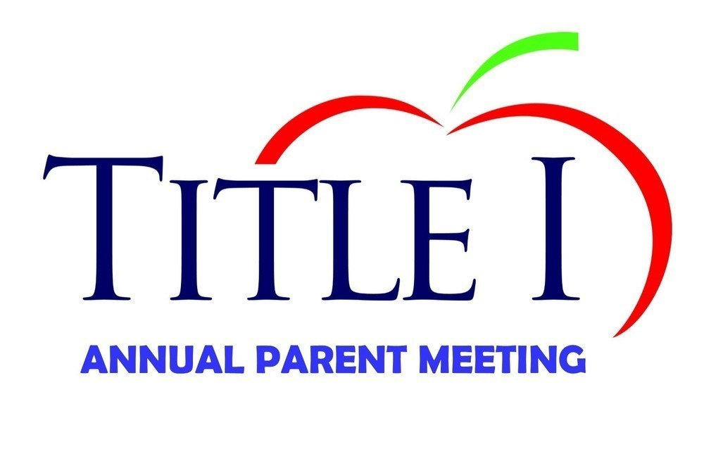

**Parents, thank you for attending your child’s recent Parent/Teacher Conferences and our school’s Annual Title 1 Meeting. We strive for 100% participation because we know that it is important for your child’s success. If you missed conferences and would like to reschedule, or would like more information about Title 1 program, please reach out to us.**

**Happy Thanksgiving**

**Thursday, November 23, 2023**

**The weather is changing**

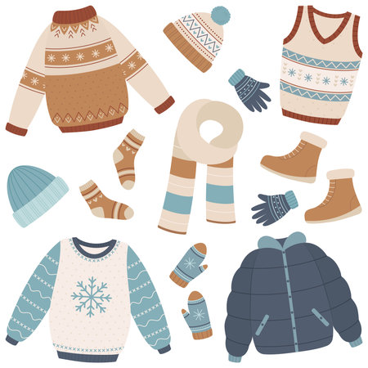

**Dear Parents and Guardians,**

**Remember, scholars go outdoors every day for recess weather permitting. Please send your child to school with the necessary clothing so that they will not be cold when we go outside. During the winter season, at a minimum, every child should have a jacket or coat, gloves or mittens, and a hat. If there is snow on the ground, snow boots and pants are necessary.**

**WHAT ARE YOU THANKFUL FOR?**

**Fill in the empty boxes?**



.

Important Dates

**District Advisory Council 11/2/2023**

**Day Light Savings (Turn Back Clocks) 11/5/2023**

**No school Attendance (Students) 11/10/2023**

**Veterans Day 11/11 2023**

**School Engagement Council 11/16/2023**

**Thanksgiving Break (No School) 11/22/23 – 11/24/23**

**School Resumes 11/27/23**

**Thanksgiving Day 11/23/2023**

**Thanksgiving Break November 22rd – 24th**

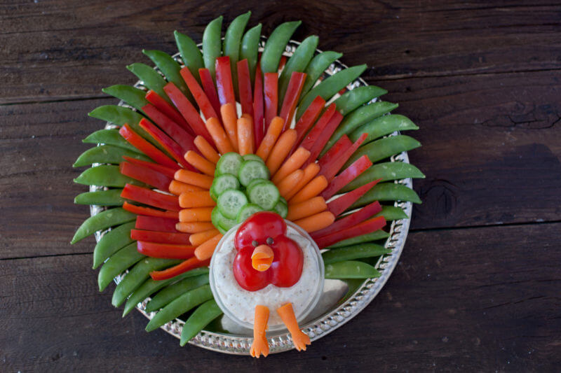

**Thanksgiving Snack for Kids**

**Turkey Veggie Tray with Homemade Ranch Dip**

**Much like the turkey fruit tray, this recipe shows how you can turn an ordinary snack into an intriguing and unique one. This veggie tray is fun to put together and you could even have your kids help you.**

**You can also provide a creamy homemade recipe or store brought ranch dip that will pair perfectly with the veggies. Create the snack together and then gobble it up together too! Enjoy!!**

**FAMILY**

**EDUCATION**

**CHILDREN**

**Good Health**

**My Dog “Feather”**

**Shelter**