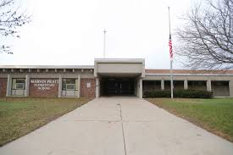

**Marvin Pratt Elementary School**

**5131 N. Green Bay Ave**

**Milwaukee, WI 53209**

**414-247-7300**

**Principal: Tianna Evans**

**Marvin Pratt Elementary School**

November 20234Newsletter

***The vision of Pratt Elementary School is to maintain its status as one of the highest performing elementary schools in the state. We will develop a society of reflective, progressive thinking life-long learners who strive to embody the spirit of innovation, active collaboration, and international mindedness in the pursuit of knowledge.***

**Veterans Day Nov11,2024**

FAMILY CONNECTION

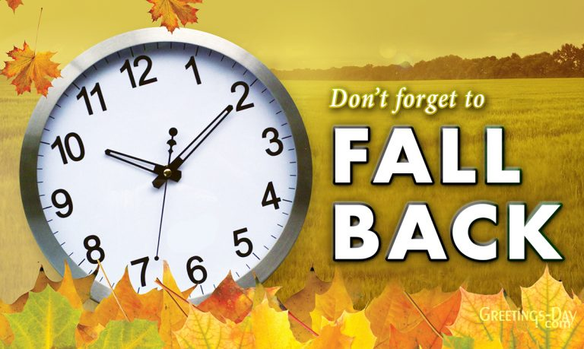

**DAY LIGHT SAVINGS!**

**GET READY TO TURN YOUR CLOCKS BACK**

**SUNDAY, NOVEMBER 3, 2024, AT 2:00AM**

**_____________________________________________________**

**SCHOOL ENGAGEMENT COUNSIL**

**SCHOOL ENGAGEMENT COUNCIL MEETS EVERY THIRD THURSDAY. A PLACE AT SCHOOL THAT BRINGS TOGETHER FAMALIES, STAFF AND THE COMMUNITY TO SUPPORT AND INFORM SHARED LEADERSHIP, EQUITY, AND CULTURAL RELEVANCE RUSLTING IN INCREASED STUDENT ATTENDANCE. NEXT MEETING IS NOVEMBER 21, 2024, AT 3:00PM**

**DISTRICT ADVISORY COUNSIL**

**THE DISTRICT ADVISORY MEETS ONCE A MONTHLY VIA ZOOM.**

**DURING THESE MEETINGS, PARENTS OF ALL STUDENTS HAVE OPPORTUNITIES TO SHARE THEIR IDEAS ABOUT THE NEEDS OF STUDENTS AND ASSIST IN THE OPERATIONS OF PROGRAMS FOR CHILDREN AND PARTICIPATE IN EVALUATING THE SUCCESS EFFORTS. NEXT MEETING IS NOVEMBER 7, 2024, AT 6:00PM.**

**join Zoom Meeting Link:**

<https://milwaukeemps.zoom.us/j/87538897498?pwd=Hm0DClZf2IuZBvWO3aXeCFF7UwoF12.1>

**Thank you**



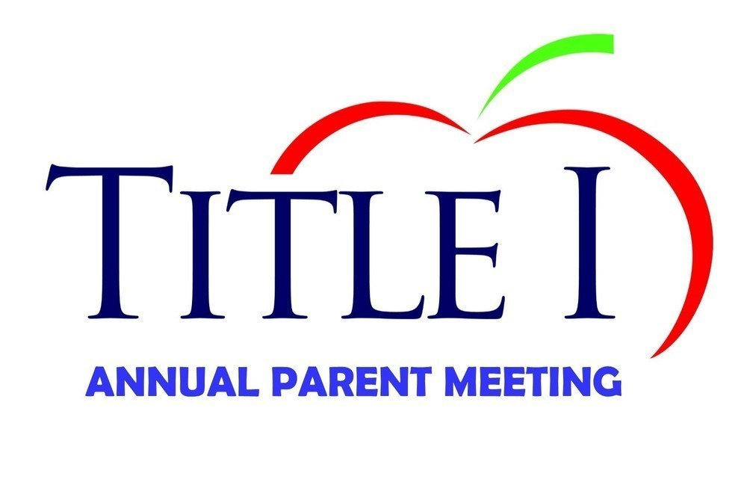

**Parents, thank you for attending your child’s recent Parent/Teacher Conferences and our school’s Annual Title 1 Meeting. We strive for 100% participation because we know that it is important for your child’s success. If you missed conferences and would like to schedule a visit, or would like more information about Title 1 program, please reach out to us.**

**Happy Thanksgiving**

**Thursday, November 28, 2024**

***Greetings Pratt families!***

***The month of November is upon us! Scholars have certainly begun to settle into routines and procedures as we continue to dive deep into our learning. At Pratt, our big attendance goal is that our scholars and staff are in school 95% of the time. We know that daily attendance is the number one indicator for student leveling the playing field for student academic success. Not only does it set a strong priority for learning for scholars, but it also reinforces scholars' academic and social experiences in school.***

***We ended the month of October with a schoolwide attendance rate of 91%. We are so close to our goal, but we need to do more! Please support our scholars in making sure they come to school each and every day. In particular, we need your help in reinforcing the understanding that EVERY day of school is crucial to future success- even Mondays and Fridays which are our lowest attending days.  Please help us meet our school attendance goal and earn your spot on the Parent Attendance Honor Roll! Thank you for your continued support!***

***Regards,***

***Mrs. Evans***

***Marvin E. Pratt Elementary School***

***Home of the “Rockets” Blasting Off to Success***

**WHAT ARE YOU THANKFUL FOR?**

**Fill in the empty boxes?**

.

**The weather is changing**



**Dear Parents and Guardians,**

**Remember, scholars go outdoors every day for recess weather permitting. Please send your child to school with the necessary clothing so that they will not be cold when we go outside. During the winter season, at a minimum, every child should have a jacket or coat, gloves or mittens, and a hat. If there is snow on the ground, snow boots and pants are necessary.**

**FAMILY**

**CHILDREN**

**Good Health**

**Thanksgiving Break November 11/27/2024– 12/1/2024. School resumes on Monday december 2, 2024.**

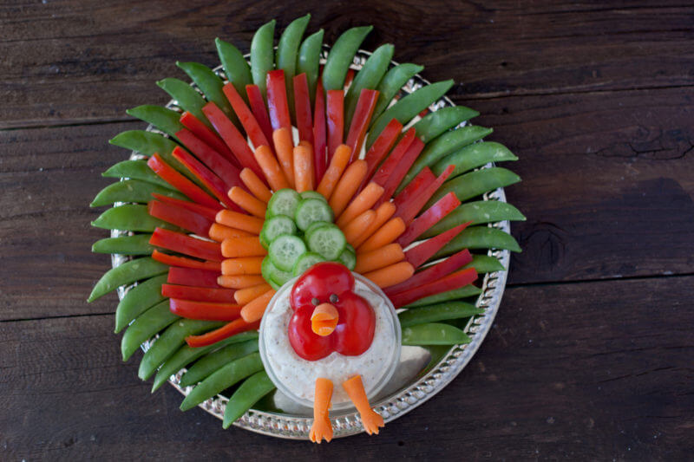

Thanksgiving Snack for Kids Turkey **Veggie Tray with Homemade Ranch Dip**

**Much like the turkey fruit tray, this recipe shows how you can turn an ordinary snack into an intriguing and unique one. This veggie tray is fun to put together and you could even have your kids help you.**

**You can also provide a creamy homemade recipe or store brought ranch dip that will pair perfectly with the veggies. Create the snack together and then gobble it up together too! Enjoy!!**

Important Dates

**District Advisory Council 11/7/2024**

**Day Light Savings (Turn clocks back) 11/3/2024**

**Presidential Election Day (PLEASE VOTE!) 11/5/2024**

**No school Attendance (Students) 11/5/2024**

**Veterans Day 11/11 2024**

**School Engagement Council 11/21/2024**

**Thanksgiving Day 11/28/2024**

**Thanksgiving Break (No School) 11/27/24 – 12/1/24**

**School Resumes 12/2/24**

**12/2/24**

**11/28/2024**

**Parent Information**

**Milwaukee Public school 2024- 2025 Calendar**

[**https://drive.google.com/file/d/1ZJel-xnv47I3TlujQWJzzUbyUzUU0xUu/view**](https://drive.google.com/file/d/1ZJel-xnv47I3TlujQWJzzUbyUzUU0xUu/view)

**Milwaukee Public Schools 2024-2025 Assessment Calender**

[**https://drive.google.com/file/d/1_AvaT4WJp9Maiof3Hc3kcs5qVgjO2f3J/view**](https://drive.google.com/file/d/1_AvaT4WJp9Maiof3Hc3kcs5qVgjO2f3J/view)

**Milwaukee Public school’s parent Campus Portal**

[**https://mps.milwaukee.k12.wi.us/en/Families/Campus-Parent-Portal.htm**](https://mps.milwaukee.k12.wi.us/en/Families/Campus-Parent-Portal.htm)

**Volunteer**

[**https://mps.milwaukee.k12.wi.us/en/Community/Get-Involved/Volunteer.htm**](https://mps.milwaukee.k12.wi.us/en/Community/Get-Involved/Volunteer.htm)

**School Engagement Council**

[**https://mps.milwaukee.k12.wi.us/en/Families/Family-Involvement/School-Governance-Councils1.htm**](https://mps.milwaukee.k12.wi.us/en/Families/Family-Involvement/School-Governance-Councils1.htm)

**District Advisory Council**

[**https://mps.milwaukee.k12.wi.us/en/Families/Family-Involvement/Advisory-Committee.htm**](https://mps.milwaukee.k12.wi.us/en/Families/Family-Involvement/Advisory-Committee.htm)

**Student Services**

[**https://mps.milwaukee.k12.wi.us/en/Families/Family-Services.htm**](https://mps.milwaukee.k12.wi.us/en/Families/Family-Services.htm)

**District News**

[**https://mps.milwaukee.k12.wi.us/en/District.htm**](https://mps.milwaukee.k12.wi.us/en/District.htm)

**Nutrition services**

[**https://mps.milwaukee.k12.wi.us/en/Families/Family-Services/School-Nutrition.htm**](https://mps.milwaukee.k12.wi.us/en/Families/Family-Services/School-Nutrition.htm)

**From the Staff and Students at**

**Marvin E. Pratt School**

**November 18, 2024**

