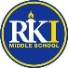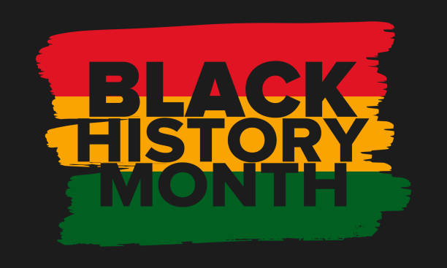

RKIMS

February Updates

**MPS Black Lives Matter Week February 6th-February 12th** - The Milwaukee community will have opportunities to listen, learn, and add their voices to the Black Lives Matter (BLM) narrative in order to bring about positive change. Leading off Black History Month in February, the national Black Lives Matter at School Week of Action, February 6–10, 2023, is designed to engage communities in discussions about the injustices of race, class, and gender.

Across the country, activities will focus on improving the school experience for students of color. Topics are centered on the Black Lives Matter at School guiding principles based upon the Black Lives Matter movement. Learn more on the [Black Lives Matter at School website.](https://www.blacklivesmatteratschool.com/)

MPS wishes to congratulate Brenda Robbins of Roosevelt Middle School for winning the Black Lives Matter at School logo contest. Her design will appear on t-shirts available to MPS students and staff.

**All events are free and open to the public. Registration is NOT required to participate.**

**No school- February 17th and 20th for Mid-Semester Break**

**IB News (Mrs. Phillips)- Our IB trait for FEBRUARY is Principled -**Students act with integrity and honesty, with a strong sense of fairness, justice and respect for the dignity of the individual, groups and communities. They take responsibility for their own actions and the consequences that accompany them.

**STAR Assessment** - Testing is over!  We’ll have a celebratory ‘Super Taco Party’ for our Top 25 STAR scorers and all students who made gains on Feb. 16th.  Did you know that over 90% of our students improved?  It’s time to celebrate!!         

**RKIMS Taco Party**- Students who have made gains on their STAR test will participate in taco party to celebrate. There will be walking tacos, snacks and beverages. For more information call Mr. Gentry or Mrs. Phillips

RKIMS will be hosting a literacy night followed by Black History Trivia **on February 16th at 5:00pm**.  Families will learn how to navigate MPS literacy device Hoopla and Milwaukee Public Library online services.  There will be many prizes and raffles.

Please RSVP: <https://forms.gle/bEcZDSAKQGqehBMW8>

Flyer: [Colorful Playful Trivia Event Flyer](https://wpsites.district.mpsds.edu/rkims/wp-content/uploads/sites/97/2023/02/Colorful-Playful-Trivia-Event-Flyer.pdf)

Virtual Link: <https://meet.google.com/crc-suqn-wby>

If you have any questions, please call Ms. Sophia at 414-616-5226.

**GE Lab News (Ms. Kridler)-** The GE Lab has been working with 6th grade to support their unit on Forces and Motion.  Students are learning about potential and kinetic energy and how to calculate them.  They are learning the beginning of algebra and how to balance equations.  Soon students will be creating a roller coaster and measure the potential and kinetic energy of it.

Some students will participate in the STEM Fair coming up and will select a problem to solve and demonstrate their knowledge of science, technology, engineering and math.  Students have had the opportunity to design in TinkerCad and 3D print a product.  Many has designed in Corel Draw and laser cut a product on one of our laser cutters.  Some are learning the soldering irons and how to program.

Students can sign up and come down to create something they have imagined!

Upcoming field experiences are to Oak Ridge Farm to do snowshoeing on February 13 and we will be visiting Jones Island to see our water treatment plant and how our innovative measures are used around the country and world.  We will also be doing a tour of Hawthorne Glen to physically see our water shed and how important it is to take care of our fresh water resource.

We may do a walking field experience to Red Arrow Park to ice skate yet this winter.

I will be working with some students after school as they have shown great interest in learning more of the equipment in the lab.

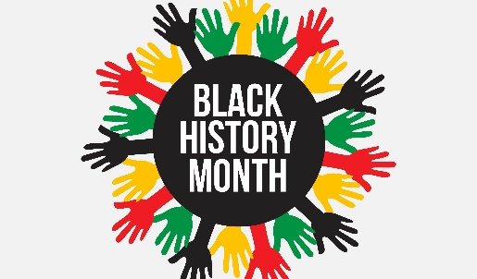**RKIMS School Engagement Council-** Will meet February 23rd at 2:30pm. Families will learn all about events/activities, budget, School Improvement plan, Staff and much more. There will be raffles for families attending. Virtual link: <https://meet.google.com/pji-erzh-cqh>