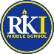

RKIMS March Updates

**No School- Friday March 17th and Monday March 20th, school will resume Tuesday March 21st**

**Reminders-** RKIMS is closed campus for lunch. Which means students can bring a lunch from home but food cannot be delivered via door dash, uber eats or families.

**Star Testing Growth Celebration March 2nd –** Students who made gains in math and reading are getting rewarded with a Walking Taco Party. Stars with each student’s name will be added to the bulletin board in the café. Over 90% of our RKIMS students made gains, CONGRATS!!!!!!

**8th Grade Completion Parent Meeting**-There will be two virtual meetings to discuss the 8th grade Completion Ceremony. Also, the size forms are due March 12th

Meeting times:

**Tuesday March 8th at 3:30pm**

**Wednesday March 9th at 11:00am**

Please plan on attending one of these important mandatory meetings.

Google Link: <https://meet.google.com/hhk-jrzs-hpv>

If you have any questions, please call Ms. Sophia at 414-616-5226.

Size Form: <https://forms.gle/D3p9RwkEUKJ4WtqY7>

**Spring Parent Teacher Conferences:**

**RKIMS Spring Parent Teacher Conferences will be in person.**

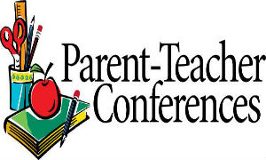**Tuesday March 14, 2023- 4:45pm-8:15pm**

**Wednesday March 15, 2023 4:45pm-8:45pm**

Communication between school and home is very important in the success of a student.  Each conference will be 10 minutes long.

As you prepare to meet with your child’s teacher make a list of things you would like to discuss.  RKIMS Teachers are looking forward to meeting and discussing your child’s academic, behavioral and social well-being. Parent Teacher Conferences will be first come first serve. Concession will be sold and there will be raffles. If you have questions, please call Ms. Sophia at 414-616-5226.

**Literacy/ Black History Night**- Our Literacy night will be rescheduled for Parent Teacher Conference Day March 14th and 15th. Families will learn how to navigate MPS literacy device Hoopla and Milwaukee Public Library online services.  There will be many prizes and raffles.

Please RSVP: <https://forms.gle/bEcZDSAKQGqehBMW8>. If you have any questions, please call Ms. Sophia at 414-616-5226.

**RKIMS School Engagement Council-** Meeting is March 30rd at 2:30pm. Families will learn all about events/activities, budget, School Improvement plan, Staff and much more. There will be raffles for families attending.

Virtual link: <https://meet.google.com/pji-erzh-cqh>

**Mrs. Phillips IB News- Our IB trait for March is REFLECTIVE-**Reflective people give thoughtful consideration to their own learning and experience. They are able to assess and understand their strengths and limitations in order to support their learning and personal development

**FORWARD Exam** - The Wisconsin Forward Exam is administered online in the spring of each school year and is designed to gauge how well students are doing in relation to the Wisconsin Academic Standards. It covers the subjects of ELA and mathematics in grades 3rd-8th, science in grades 4th and 8th, and social studies in grades 4th, 8th, and 10th.

**Please ensure that your student is in class on their testing days.***Please remind your student to bring pencils, paper and notebooks to class every day.  They may purchase pencils 2 for 25 cent and notebooks for 50 cents.  Mrs. Phillips, Room 121.*

**Ms. Kridler GE Lab Coach**- Students will be going to Hawthorne Glen at the end of March to study a real-life water shed and do various demonstrations as well.  Our Milwaukee County Zoo trip will hopefully be rescheduled as there a bus company issue. Students are working diligently on their Energy brochures and some are working on their STEM Fair research of designing Tiny Houses with alternative energy sources such as solar.

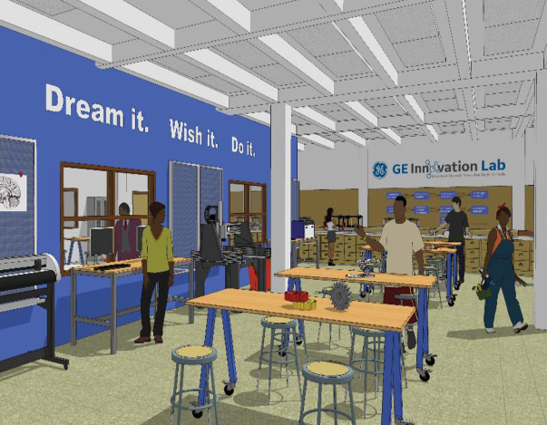We have three UW-Milwaukee Architecture students coming twice a week to mentor and support our 6th graders with their Design Process work for this project.  Those attending the STEM Fair will participate in a walking field trip to downtown Milwaukee to see the architecture in our Third Ward historic area and we'll visit the Public Market for lunch and likely stop by Milwaukee School of Engineering and even Milwaukee Institute of Art and Design.

Some students just earned a pancake breakfast and it demonstrates conduction and convection they are learning in science.

Unfortunately, our snow shoeing trip was cancelled due to staff shortages in February but we are planning on visiting Urban Ecology Center to get some of our volunteer hours in as an IB student and we'll participate in removing invasive species in our area. Some students will work with Gear Box Labs and learn to code Arduinos to solve various problems.  We will also design stickers on our vinyl cutters and create a family crest to take home.

Come see what's happening in the lab!

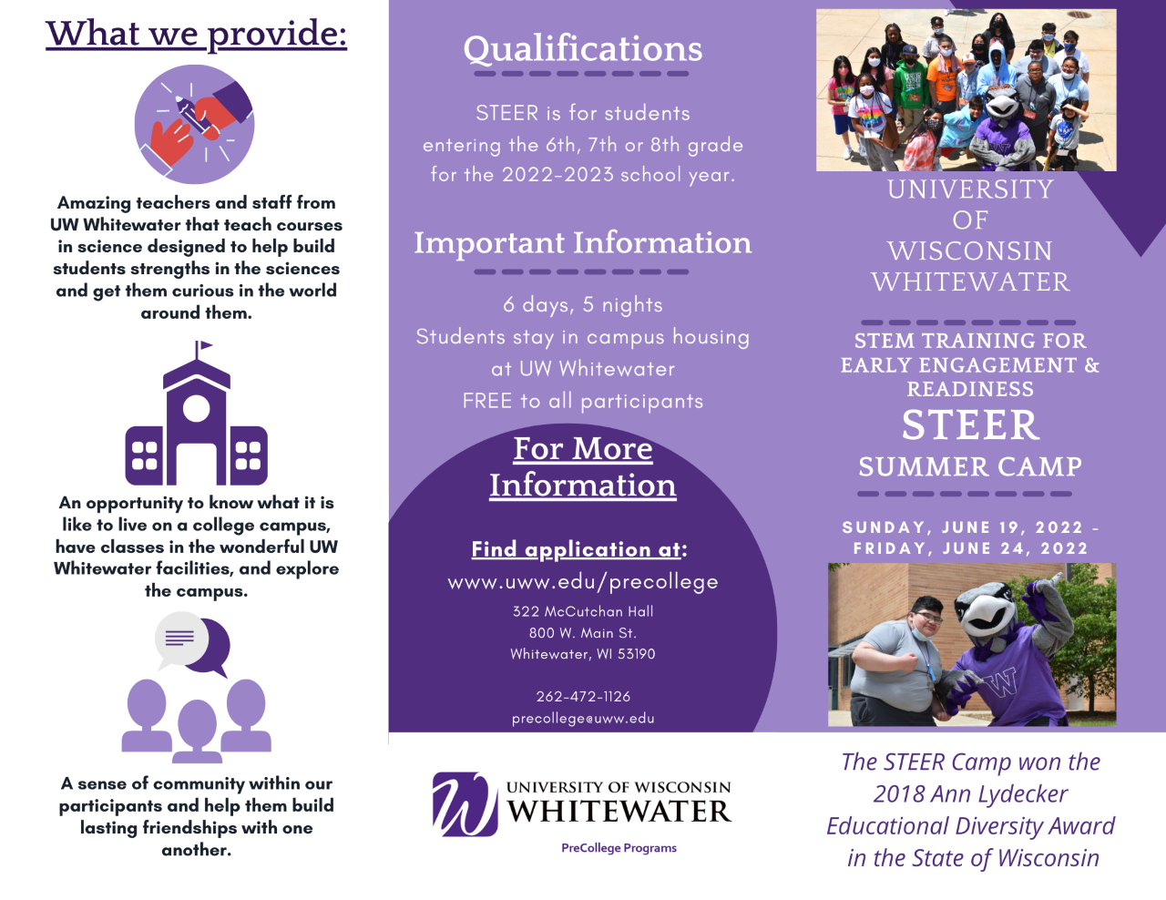**Resources:**