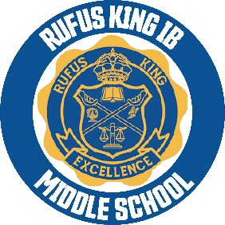

**RKIMS September 2023 Updates**



**No School- Friday September 1st and Monday September 20th**

**RKIMS School Engagement/ Title 1 Meeting- September 20, 2023 at 2:00pm (virtual link:** [**https://meet.google.com/dpu-cjnr-ggt**](https://meet.google.com/dpu-cjnr-ggt)**)**

**No School- September 29th**

**Reminders-** RKIMS is closed campus school for lunch; which means students can bring a lunch from home but food cannot be delivered via door dash, uber eats or families.

**RKIMS School Uniform Gear -**RKIMS has school uniform gear available in the office, ready for purchase. Click on the link to see what’s available: <https://docs.google.com/document/d/17foZ-De5OPSogAqJaaoutuB4AXe4T6_t6ePaBNkgnsA/edit?usp=sharing>

Follow us on social media:

* Website: <https://wpsites.district.mpsds.edu/rkims/>
* Text Message:  text 67587 to receive important text messages to your phone
* Facebook: <https://www.facebook.com/RKIMSMPS/>
* Instagram: <https://twitter.com/ms_rufus>
* Twitter: <https://twitter.com/ms_rufus>

**IB News- Our IB traits for September are:**

* **Knowledgeable**- explore concepts, ideas and issues that have local and global significance. In doing so, they acquire in-depth knowledge and develop understanding across a broad and balanced range of disciplines. **IB** students are extraordinarily well prepared for the academic requirements of university coursework.
* **Thinker**- They exercise initiative in applying thinking skills critically and creatively to recognize and approach complex problems, and make reasoned, ethical decisions.
* **Open-Minded**-They understand and appreciate their own cultures and personal histories, and are open to the perspectives, values and traditions of other individuals and communities. They are accustomed to seeking and evaluating a range of points of view, and are willing to grow from the experience.

Elevate Parent and Student Accounts:

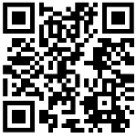

Elevate Parent Portal:

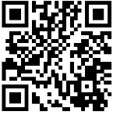

Elevate Student Portal:

**Ms. Kridler GE Lab Coach**- Welcome back to Parents/Guardians of RKIMS,

In the GE Lab, we are starting with an exciting opportunity for 7th and 8th graders to attend four workshops hosted by Milwaukee School of Engineering with a grant funded by Generac for our students to learn more about engineering principles.  The grant is written for the same students

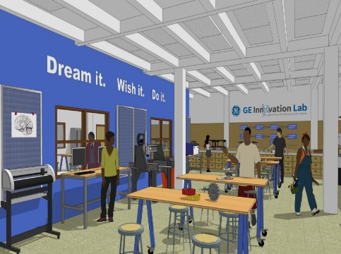to come for the four-week experience.  We will be there for four mornings on Wednesday starting September 15. I have another opportunity for students to attend a field trip to the Milwaukee Public Museum on October 18th.  We will tour the museum and also see the IMAX experience, Into America's Wild.

We will be starting an after-school program due to a partnership with RiverEdge Nature Center to encourage environmental science and how to incorporate the lab and all of the equipment to solve real world problems.  Again, we are planning on going to RiverEdge in Saukville to test the health of the health of the Milwaukee River.

Students have been able to take tours in the GE Lab, we have done Design Challenges with all of the 6th grade students and all students must take the GE lab safety test and accomplish a 100% in order to proceed with endeavors in the lab.  All students must take the test for each piece of equipment and receive 100% on the test in order to use any and all equipment in the lab.  I will provide PowerPoints and guide students about all aspects of the lab.

Some of our STEM Team students from last year have been busy working in the lab to create signage for classroom teachers using our vinyl cutters, laser cutters and 3D printers.

All students are welcome in the lab by following simple rules of being kind, respectful and a have a willingness to try.

We are so fortunate to have this lab for us to use and I want all who are interested to come and explore!

I'm hoping to have even more students participate in our STEM Fair and other competitions throughout the year.

Welcome back!

**Ms. Susan Kridler**

**GE Innovation Lab Instructor**

**kridles@milwaukee.k12.wi.us**

**Resources:**

MPS is offering free virtual tutoring for the 2023 - 2024 school year.  Parents can use this link to sign up: [Parent Tutoring Request](https://app.smartsheet.com/b/form/feb2e69bb3b349b08d5d86e5a59c590e).

Free Homework Help Websites

1. **Khan Academy** short lessons in the form of videos. The website also includes supplementary practice exercises - [www.khanacademy.org](http://www.khanacademy.org)

1. **Brainpop** animated educational site for kids - Science, Social Studies, English, Math, Arts & Music, Health, and Technology. - [www.brainpop.org](http://www.brainpop.org)

1. **Socratic** brings you visual explanations of important concepts in each subject. - <https://socratic.org>

1. **Fact Monster** A free reference site for students, teachers, and parents. Get homework help and find facts on thousands of subjects - [www.factmonster.com](http://www.factmonster.com)