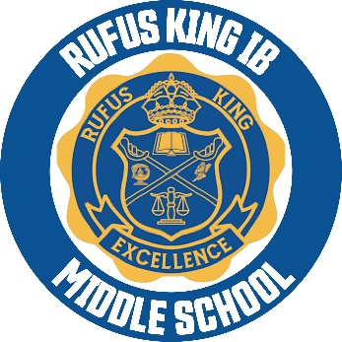

April 15, 2024

Dear RKIMS Parents/Guardians:
In just a few weeks your child will be completing middle school and heading to high school. This letter is to keep you informed about the guidelines that must be adhered to in order for your child to participate in the eighth-grade end of the year activities and celebrations.
You should have already attended the 8th grade meeting and received the PowerPoint. The following are a couple of reminders and expectations that will be enforced…
- Students must be proficient in ALL academic areas to participate in the completion ceremony.
- No suspension and/or no more than 2 discipline behavior referrals starting April 1st
- No unfinished business after May 10th. All obligations must be cleared up, including fees.
- Chromebooks must be returned by May 10^{th.}
- Passion Projects, Star, Forward assessments are completed.
This year’s completion will take place Monday, May 20, 2024, at 10:00 a.m. Each student that meets the completion requirements will receive three tickets with an option for one additional. Student fees include the cap and gown and all 8th grade activities (action territory, etc.) please see PowerPoint for additional information. Students’ fees are due immediately. Please call the school counselor or 8th grade teachers to find out more about your student grades.
Remember that we are not required to conduct a completion ceremony, however it is important to remember that is a celebration of achievement rather than a mere rite of passage. Please discuss academic and behavior expectations with your child in order to participate in end of the year celebration activities. If they do not fulfill these requirements, your child will not be allowed to participate.
Feel free to contact administration or our parent liaison if you have any questions.
Thank you,
Ms. D. Ellis
Principal

