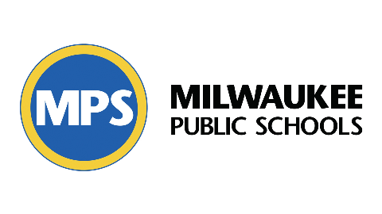

Dear MPS Parent,

Student well-being is an important part of social-emotional health. Student education improves when we pay attention to well-being. Milwaukee Public Schools wants to improve student well-being. MPS listens to student feedback to enhance our students’ learning experience.

The Student Well-Being Survey is new this year. Students in third through twelfth grade will give feedback using this survey. The survey asks students to rate their feelings and experiences at school.

This survey will be taken three times per year: October 7–18, 2024; January 6–17, 2025; and May 5–16, 2025. The survey will take about 15 minutes. The results will not identify your child. Your child’s individual responses will not be viewed by school staff. Student responses will be grouped to help staff choose schoolwide supports and services.

If you do not want your child to share their feedback, please call your child’s school to inform them of your request.