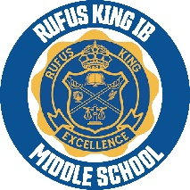
RKIMS February Updates
Important Dates:
No school Monday, February 17th and Tuesday February 18th.
School will resume Wednesday February 19th at 9:05am.
Events:
Honors Breakfast February 7th, students who received proficient and advances on their report cards for the 1st and 2nd semester will be celebrated with a hot breakfast provided by RKIMS.
Lunch With Someone You Love February 14th at 11:00am-12:30pm. RKIMS will be having a family appreciation lunch, and students can invite a special person to have lunch with them.
We are the Drums (all school field trip) February 27th. Field trip slips will be handed out soon, all students must attend, it’s free of charge.
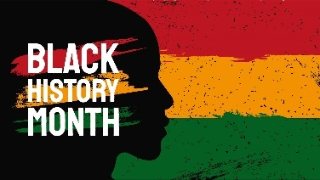
Black History Program “Through the Music”- Student will express what Black History means to them through visual arts (singing, dance, poems, skits and more)
There will be a performance for students and a separate one for families.
On February 26th there will be a performance for the student body.
February 28th at 2:30pm there will be a performance for families. Please enter the building on Palmer Street.
If you have any questions, please call 414-616-5226.

